NATIONAL SELF-DIRECTED SUPPORT COLLABORATION
NOTE OF MEETING – 10TH MAY 2023

In attendance by video conference:
Donald McLeod (SDS Scotland) (chair) | Sarah Anderson (SDS user, SW student and Community Broker) | Rachel Mason (Self Directed Support Consultant/24/7 Grid)
Rhonda Alexander (East Ayrshire Council) | Robert White (ILF Scotland) | Philippa Harrop (Voice Of Carers Across Lothian)
Sharon McLeod (Ayrshire Independent Living Network | Susan Kelso (Personal Outcomes Network | Violet Keenan (SDS Forth Valley)
Yvonne Nova (Scottish Government) | Lisa Ehlers (Inclusion Scotland) | LizAnne McCahill (Ark Housing)
Louise Officer (Care Inspectorate) | Lyn Pornaro (Disability Equality Scotland) | Ruth MacMillan (Shetland Islands Council)
Margaret Petherbridge (SDS Practice Network) | Mark Han-Johnston (SDS Scotland) | Morag Duncan (Dundee Carers' Centre)
Nicoletta Primo (Sight Scotland) | Pauline Lunn (In Control Scotland) | Frank Reilly (SASW)
Hannah McShane (Scottish Government) | James McNulty (Scottish Government) | Jaynie Mitchell (Coalition of Carers in Scotland)
Edward Inglis (SDS Forum East Renfrewshire) | Joanne McGee (Glasgow Centre for Inclusive Living) | Kayleigh Hirst (SDS Scotland)
Laura Hendry (Cornerstone SDS) | Les Watson (Personal Assistants Network) | Ali Upton (SSSC)
Becs Barker (Community Contacts) | Carrie-Anne French (East Ayrshire Council) | Catherine Garrod (CCPS)
Claire Roxburgh (East Ayrshire Council) | Jill Fraser (Inspiring Scotland) | Elspeth Critchley (Encompass)
Fran Holligan (COSLA) | Jane Kellock (Social Work Scotland) | Sheila Hanney (Key/Community Lifestyles)
Laura Finnan Cowan (Social Work Scotland) | Donna Murray (Social Work Scotland) | Calum Carlyle (Social Work Scotland) (minutes)
Welcome and Matters Arising | Actions
DMd welcomed the group and extended thanks to those who fed back on the SDS Improvement Plan by the deadline of 7 April.

Apologies were noted from: David Berry, Hazel McFarlane, Gordon Dodds, Simon Webster, Heather Mole, Des McCart, Alan Bigham, Becky Duff, Nicoletta Primo, Lisa Ehlers, Gordon Dodds, Martin Kettle and Andrew Godfrey-Meers

The previous meeting minutes were approved by assent.
No matters arising.

National SDS Collaboration | Actions
Terms of Reference and Membership Criteria  The group discussed the membership criteria for the national SDS collaboration.  (double click to open this document)  Discussion:  – The criterion for membership of this group is that you have an interest in SDS improvement and implementation, to participate in policy and rights-based work, and I suggest that membership should be open to both individuals and organisations.  – Agreed, the group needs to be about actions to move things on as regards SDS implementation and improvement.  – While SSSC aren’t directly involved in SDS implementation, in terms of supporting the workforce, this group is valuable, in providing perspectives, eg from experience and lived experience, that can be taken back to teams within SSSC, who are working in Social Work education, for instance. The intelligence feels really valuable for sharing with colleagues in SSSC.  – Similarly, the Personal Outcomes Network is not directly involved in SDS implementation, but we have direct connection with those that are, and we are happy to continue to contribute and support SDS implementation to support the infrastructure changes that are required to support the workforce.  JK – Open membership has worked well so far, but we need to continue to differentiate between this group and the SDS Community of Practice, which is becoming a vibrant and safe space for Local Authority (LA) representatives, and a group where there is more focused work specifically for the Social Work workforce.  – The group should hear regular updates from all of the Scottish Government (SG) grant funded organisations (In Control Scotland, SDS Scotland, Social Work Scotland and the Health and Social Care Alliance).  – In Control Scotland have been running online lunchtime sessions since the start of the pandemic, where anyone is welcome including people using services, carers, people working in advocacy etc. This year, we are introducing a change to that. The regular sessions  Can become a bit repetitive to some regular attendees, so we are putting in place a quarterly network to bring particular challenges and co-produce solutions together. We see this group (NSDSC) as the level above that, talking at a national level.  JK – It might be good to invite members of the SDS practice network into that network as well, since their focus is practice-based solutions. | Action: JK and DMd to review the terms of reference to see if any changes should be made, and if so, circulate the updated version for consideration by the group.

SDS Project Workstreams and the Review of the SDS standards | Actions
The SDS project team talked about the work being planned for the next financial year, with a particular focus on the review of the SDS standards.  The team presented a set of slides to provide more information:  (double click to access this document, please note there is additional information in the comments section beneath each of the slides. If the slides come up without comments being visible, you can see them by right clicking on the screen and select “presenter view”.)  Group members were invited to consider whether they would like to be part of one or more of the work streams.  Comments and discussion:  – Is there a draft of the practitioner guidance available?  DM – There isn’t a draft practitioner guidance yet, however there is a draft toolkit, which you would be very welcome to look at. We are still taking feedback on that.  – Under the training and development workstream, as well as linking to advanced practice, we need to also link to the future proofing of the register and what will be the new model of continuous professional learning (CPL). There will be a move towards recommended learning for groups on the register including Social Workers. Maybe a message can go into the toolkit relating to CPL?  – Good SDS approaches will always develop out of relationship-based practice, and we need to make sure this message is embedded from the beginning, so this ties in with the training and workforce development work from the outset. Social Workers also need to be more confident about how to set budgets if managers are to be confident in delegating that responsibility, which again ties in with making sure that the training and practice development is really good on that. Since this all comes back to personal outcomes, this shouldn’t be a problem, unless it’s risky or there are legal issues. This should tie in with the review of the SDS standards. SDS Forth Valley have developed some really good video resources explaining how the legislation and SDS statutory guidance applies in practice.  JK – Last week, we spoke to the SDS community of practice about the workstreams, and asked them to consider which workstreams they would like to be involved with, and we would like to extend that invitation to the national SDS collaboration as well. The SDS project team can be contacted at sds.team@socialworkscotland.org. Also, if there is work happening more widely (eg outside of Scotland) or experts who are not part of this group but who should be involved, please also let us know. One thing we have heard from leaders is that the standards should be clearer on actions  – Lothian Centre for Inclusive Living are working with Napier University Social Work Students, OTs and physios to look at the modules and the assessments, which has highlighted the importance of lived experience, looking at whether people have actually received the support they need and taking an action focused approach. Also, we should note that in some cases the workforce have been empowered, while the disabled person hasn’t had that choice and control passed on, because they’ve always been presented with this is what you can have because that’s what’s available. One other thing, we are talking about making the toolkit and SDS standards available and accessible to everyone that requires it, so in this process let’s make sure that they really are accessible to all that require them, and speaks to people wherever they’re coming in at, whether they’re an agency support worker, or a Social Worker or anyone else.  – The biggest thing here is collaboration. There’s a lot of good practice going around that’s maybe not being advertised. GCIl and Take Control offer support in four local authority areas, including care manager workshops, inductions for Social Workers, talking about the statutory guidance and SDS legislation. We deliver training with SDS leads on the four options and other things. We do pre-assessment workshops as well. It’s about joining the dots to bring practice together. Also, when can we expect the practice guidance to be available?  DM – The SDS toolkit is still under development, but that will lead into the development of practice guidance. The toolkit has had a lot of co-produced work done on it, and this will be available very soon, and based on the learning from the review, this will feed into the development of practice guidance.  – I wanted to reiterate the point about investing in what people actually want. People will only ask for what they can get, so it’s misleading to say that people only want this or that service (eg. respite, building based day centres etc). Unless we invest in families, individuals and unpaid carers to show them what better looks like, we will go round in circles. Some practitioners use this as an excuse not to do better. Also, people who are used to “traditional” services won’t usually jump into something new. They might dip their toe into something creative, but they will be fearful of losing what they currently have, even if it’s awful. At the moment the disparity of available information in rural communities and the islands is shocking, but many people don’t know their basic rights, and often Social Workers and managers don’t know the legislation. There is so much work to be done. Where I see it working is where we invest in families, unpaid carers and individuals, not workers so much, because workers leave, change jobs, get promoted, and move around. Supported people don’t leave, they live it. People need to know what they are entitled to so they can demand it, and at the moment they are not being told what those are.  – Eligibility criteria is a nightmare, and it’s good to hear positive examples from around the country, but if it’s in pockets, it’s difficult to see that things are improving. There needs to be a way to feed that improvement back to service users. Also, supported people’s stories and experiences should be front and centre. Supported people are being asked to tell their stories but very little changes.  LFC – I have reached out to the People-Led Policy Panel to include them in this work, and to give them the opportunity to explore how and why things should change.  – We (a SiRD project) are approached regularly by Local Authority Colleagues for support with recruitment, but not about rights. How do we make sure we fully understand what a rights-based approach means? We need to raise awareness and try to present a rights-based approach to Local Authority colleagues more as collaboration and not as something threatening. The mechanism of SDS, human rights, peer support and independent support all need to go together to make that happen. | Group members were invited to consider whether they would like to be part of one or more of the work streams.

National Self-directed Support Stakeholder Updates | Actions
In Control Update (PL) – Please see the latest newsletter from In Control (click link) as well as the following slides for an update on the development work ICS are doing to develop SDS implementation:  (double click to open these powerpoint slides)  SDS Scotland Update (DMd) – The main focus will be capacity building for independent support organisations (ISOs), and also to launch a new online SDS handbook providing information at all levels, so there is one portal for everyone seeking information. SDSS will also be looking at a quality analysis with ISOs partly in conjunction with Social Work Scotland, using a self-evaluation process.  The programme of training for members continues, as does the annual conference The National Voice, and a focus on some of the marginalised communities identified through the improvement plan (with implementation groups for addictions and dementia).  The National Brokerage Framework is now in year two of its development, including delivery of the Brokerage Aware and the Community of Practice. At least twelve organisations are committed to that award.  SDSS will also be holding information sessions on the PA handbooks with a focus on PA employers, development of the PA employer handbook and testing the self-evaluation tool.  SDSS have received funding to provide a training framework for Personal Assistants and employers, which will take a two-pronged approach, looking at training for PAs but also routes into social care for those seeking to be PAs. Two staff members have been recruited to devise the training framework over the next year.  Also, please see the following slide for a summary of the work of the PA Programme Board:  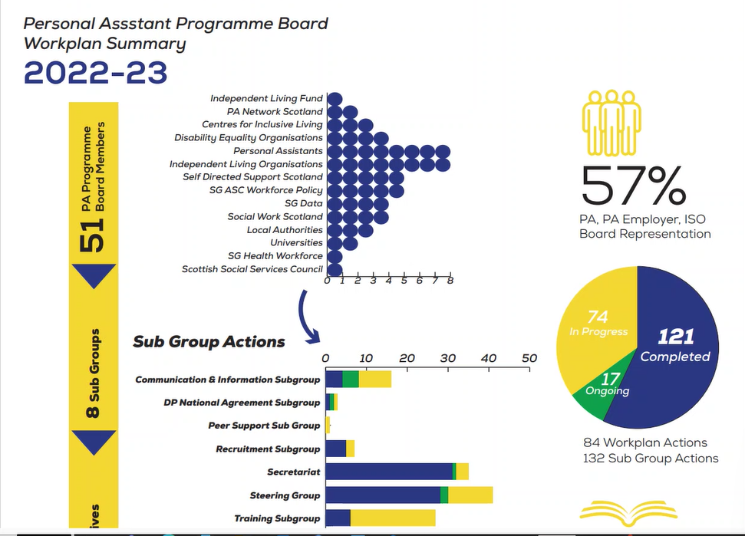  Inspiring Scotland Update (JF) – Inspiring Scotland is the strategic delivery partner for the Support in the Right Direction (SiRD) portfolio of support and advocacy organisations. This is the sixth year of the project, and there are currently thirty organisations funded across Scotland. Reports are being received and compiled from SiRDs about year five and once these have been collated into a summary report (over the next month or so), you will be able to see this information on the Inspiring Scotland website.  From April 2024 onwards the SiRDs will be operating under a refreshed SiRD operating portfolio, currently being developed in collaboration with Scottish Government. The new funding programme should be ready to launch by later this summer.  All group members were encouraged and welcomed to present any relevant updates to the national SDS collaboration at future meetings. | All group members were encouraged and welcomed to give updates to the national SDS collaboration at future meetings.

Scottish Government Update (JMy) | Actions
DMd thanked everyone who fed into the development of the SDS Improvement Plan, and mentioned the appointment of Maree Todd, the new Minister for Social Care, Mental Wellbeing and Sport.

JMy reported that the SDS improvement plan has been finalised and approved by the Minister, and now awaits approval from the COSLA Executive Board (next meeting on 19 June). The plan can then hopefully be published within a few weeks. There will be a further update about communicating the plan at the next meeting.

As far as a monitoring and evaluation process, the intention is for this to be developed this summer, possibly in conjunction with the SDS Evaluation work stream. It’s important to take a learning approach with a focus on improvement, as well as to listen to the voices of lived experience. We need to develop a way to report annually in a more consistent way on progress of SDS implementation as well.

YN reported that almost all of the funded projects have had their funding agreed and letters sent out. The Minister has also agreed to a slight increase in SDS transformational funding in recognition of the good work that the SDS leads are doing. Monitoring and evaluation of the outcomes will be attached to that (eg. local implementation plan being implemented, having a dedicated SDS lead, addressing implementation issues).

Any Other Business | Actions
The next meeting of this group will be on Wednesday 7th of June 2023 from 1pm-3pm. Click here to join the meeting.

