NATIONAL SELF-DIRECTED SUPPORT COLLABORATION
NOTE OF MEETING – 7 JUNE 2023

In attendance by video conference:
Donald Macleod (SDS Scotland) (chair) | Mark Han-Johnston (SDS Scotland) | Gaby Nolan (Lothian Centre for Inclusive Living)
Kayleigh Hirst (SDS Scotland) | Les Watson (Personal Assistants’ Network) | Pauline Nolan (Inclusion Scotland)
Philippa Harrop (Voice of Carers Across Lothian) | Sarah Anderson (SDS user, SW student and Community Broker) | Sharon Mcleod (Ayrshire Independent Living Network)
Robert White (Independent Living Fund) | Sheila Hannay (Key/Community Lifestyles) | Violet Keenan (SDS Forth Valley)
Nicoletta Primo (Sight Scotland) | Carla Bennett (Voice of Carers Across Lothian) | Cheryl Taylor (SDS Practice Network
James McNulty (Scottish Government) | Elspeth Critchley (Encompass) | Margaret Petherbridge (SDS Practice Network)
David Berry (Scottish Government) | Alastair Minty (In Control Scotland) | Jen Grundy (City of Edinburgh Council)
Hannah McShane (Scottish Government) | Pauline Lunn (In Control Scotland) | Joanne McGee (Glasgow Centre for Inclusive Living)
Ekaterina Todorova (Carr Gomm) | Janis MacDonald (Health and Social Care Alliance) | Gaby Nolan (Lothian Centre for Inclusive Living)
Ashley Drennan (Inspiring Scotland) | Andy Miller (Scottish Commission for People with Learning Disabilities) | Agnes Hadden (Take Control/Glasgow Centre for Inclusive Living)
Becs Barker (Community Contacts) | Elaine Torrance (National Development Team for Inclusion) | James Cronin (Scottish Government)
Brett Rogers (In Control Scotland) | Jaynie Mitchell (Coalition of Carers) | Sandy Hunter (Wheatley Care)
Rhonda Alexander (East Ayrshire HSCP) | Carrie-Anne French (East Ayrshire HSCP) | Jane Kellock (Social Work Scotland)
Donna Murray (Social Work Scotland) | Laura Finnan Cowan (Social Work Scotland) | Calum Carlyle (Social Work Scotland) (minutes)

Welcome and Matters Arising | Actions
DMd welcomed the group and invited new members to introduce themselves.

Apologies were noted from: Lisa Ehlers, Iain Ramsay, Becky Duff, Simon Webster, Catherine Garrod, Des McCart, Jill Fraser, Laura Hendry, Catherine Mathieson, Emma Miller, Anne-Marie Monaghan, Lyn Pornaro, Ellie Clark and Ali Upton

The previous meeting minutes were approved by assent.

Matters arising – JK and DMd will review the terms of reference after the SDS implementation plan has been published.

DmD mentioned the SDS Improvement Plan which will be published later this month. KH shared the following diagram, to illustrate where people could get involved in SDS improvement work.

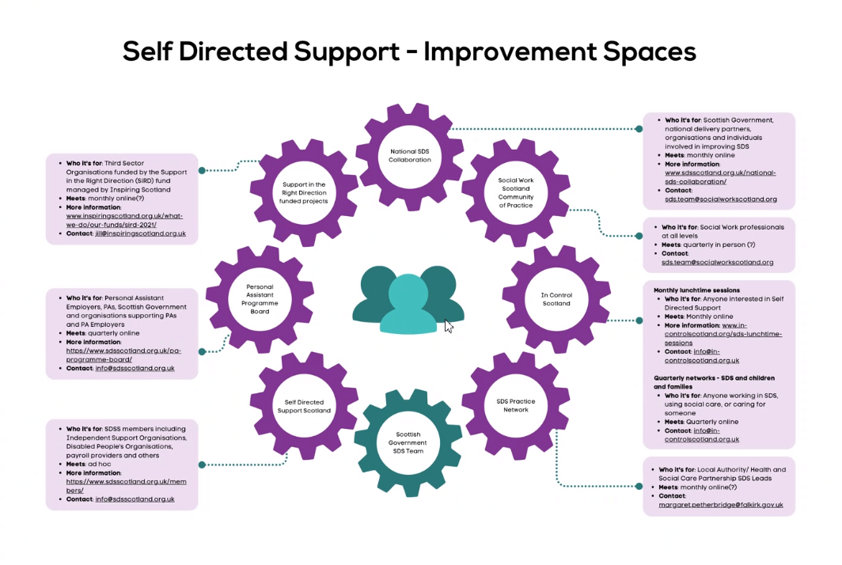

Scottish Government Updates | Actions
SG Work on Eligibility (AMd) – Through the Independent Review of Adult Social Care, a lot of feedback was received about the issues with eligibility criteria as they are currently applied. Scottish Government (SG) responded by looking to how eligibility can be approached with a human-rights approach. SASW are taking on a piece of research around eligibility, led by Emma Miller of the Personal Outcomes Network.

The ambition is for Ministers to have control over any changes made, which will not be incidental. To do this, Ministers need to be fully informed.

The work is fully connected with the development of the National Care Service. Please see the joint statement of intent and next steps for more information.

Please also click here for more information including presentations from Andrew Macdonald, Emma Miller and Sarah Waite on Rethinking Eligibility.

Discussion, comments and questions:

PL - We had an interesting experience in a meeting yesterday of interpretation of eligibility criteria being used as a means to avoid SDS - if people are in critical need they're in crisis therefore only option 3 offered. Only one authority involved, and not sure if it's a rogue worker or broader practice, but we're doing a bit of digging into this to find out more... would be interested to hear if anyone else has come across this.
PN – We have heard about this happening in another LA area as well.
SH – And we have an example in another area.
RW - I know this can happen if there is an urgency eg. Hospital discharge, if used otherwise it would appear to be avoiding duties under the Act.

BB – Is a draft available of what the new eligibility criteria might look like? At the moment only people with critical or substantial need can often access social care, so how will that change?
AMd – At the moment people who are not in those categories might be signposted elsewhere or they might not, but they need to be in those categories to get formal support, and this can affect the way that Social Workers talk about cases. It’s too early to say what the new criteria might look like at this stage, as we are still doing the research, and this applies also to the work on unmet need. By March 2024 we will be in a position to make recommendations, but we can’t pre-empt what those might be at this stage. Our commitment is to co-design everything as much as possible, so if it is identified that a more radical approach is needed, we would seek to co-design that approach.

RW - Immediate improvement to the current eligibility criteria (designed to allocate short visits to older people) would be to have national guidance on the definition of “critical” which is research based, eg. potentially including agreement that social support needs are longer term critical - that critical cannot only be applied to immediate need.
PL - I fear it's the latter - the person has said there's no particular crisis, there's will and capacity to make decisions. Also if there was a measure put in place for good reason you'd expect it to be temporary and a reassessment when crisis calms down, but this hasn't happened either.

MHJ - I wonder if 'getting rid' of eligibility criteria might be on the agenda for discussion as there are specific examples of this happening in support for carers for example?
ET – There is evidence that providing support at an earlier stage (for carers and supported people) can stop people from finding themselves in substantial or critical need. Eligibility criteria also pushes you down a deficit model rather than an asset-based approach.

DM - NDTi has collected a growing body of evidence that shows the value of Community Led Support over a period of eight years, here is a report about the economic case for strengths based Community Led Support.

MHJ - A 'Good Conversation' leading to relevant support?

BB - Eligibility criteria can become something to hide behind- 'it's not my decision, gov!' Almost 'computer says no.' that only erodes relationships and trust between statutory workers and supported people.

AM - Someone said to me the other week, assessment is where you explain to me why I can't have what I didn't want.

SDS Improvement Plan (JMy) – The SDS Improvement Plan, following lots of engagement work, has been approved by the Minister a few weeks ago, and has now been signed off by COSLA. It will be published on the SG website on 12 June 2023, as a PDF version and a web version.

JMy will be putting together a monitoring and evaluation paper, for discussion with members of the National SDS Collaboration, so we can look at what’s been done in the first year of the report, ensuring that supported people’s input is considered as part of the evaluation.

There is an opportunity to have an introductory chat, about the SDS Improvement Plan and the national SDS collaboration in general, with the incoming Minister Maree Todd next Tuesday (13 June) at 9am if there are group members who would like to attend. (names were put forward to represent the national SDS collaboration at this meeting).

JK and BB will begin the meeting with a brief overview of the national SDS collaboration.

Questions and discussion:
PN – Will there be accessible explainers or an accessible version of the SDS Improvement Plan.
JMy – SG don’t usually make easy-read versions of these kinds of documents, due to the length and the way it has been written. If there are audiences that might benefit from a more accessible summary, then that would be worth looking into. I’ll take that away and come back on that.
AMy – It would be more useful if we can hear about any issues around producing easy-read versions, with a transparent approach to any difficulties, to avoid having too long a delay before easy-read versions become available.
DM - Could a video with text be made. Like the one Mr Stewart did about the SDS Statutory Guidance?
PL - Even a one pager can be totally inaccessible in its language, I definitely agree we should have accessible info. ICS might be able to do a version fairly quickly if it would take a long time through SG.
DM - If people are to be involved in the evaluation and learning about the plan, they need to be able to understand it.
BB - I agree, but I also question how understandable accessible versions are and I think the video idea is a really good addition.
JMy - Thanks for this idea - I think this worked well when we did it for the SDS Guidance (an 80 page plus document), and while the Plan is way less complex, it could be a useful way of helping folk engage with it. We'll have a think about this and get back to the group.

National Dementia Strategy | Actions
(double click to open this document)

DB presented on the national dementia strategy (see presentation slides above).

Discussion and questions:
KH - Thanks for a helpful presentation David. We've published an article highlighting the ambitions specifically around SDS in the strategy: https://www.sdsscotland.org.uk/scotlands-new-dementia-strategy-and-sds/

BB – In some cases, people are not able to choose an option that would give them choice and control due to a lack of availability, or in other cases, people are left with more responsibility than they would like because only Option 1 is available in so many rural, remote and island communities

SA – There is a link between substance/alcohol use and dementia, but people using substances often don’t receive SDS, and don’t even apply for it, partly due to stigma.

MP – The importance of early support/ prevention and advice is invaluable.
DM - Links with health colleagues are also vital.
ET – Yes, the importance of early support/ prevention and advice is invaluable - we discussed this in terms of reviewing eligibility criteria.

DM - Increasing the knowledge and confidence of our Social Workers in using an SDS approach to support people living with dementia is really important.
JMe - Social workers will only offer SDS support once a person has had an assessment and a diagnosis of Dementia, delaying the process significantly.

JMe - We need a joined up approach from social work, carers centres and Independent organisations
BR - I agree but would add Health as well.

LFC - There's huge inconsistency across the age range about what should be expected in terms of support and more broadly, a good life.
SA - and sadly assumptions that just because you're a certain age that you want certain things. which isn’t true.

BB - We should invite reps from the National Dementia Link Workers Network to this meeting and to the SiRD monthly meetings.
PL - Great point Becs - and also back the way as evidence shows that only about half of newly diagnosed people access post diagnostic support: there might be folk at your doorstep that you could link in with specialist workers, but without shared knowledge folk fall through the gaps.
LFC - Maybe we could ask for Nurse Consultant representation too?

DM - In rural remote communities there is often 'whole community approach' to supporting people living with dementia - Dementia Friendly Community (eg. health, housing, community planning, volunteers, church, social work).
JMe - Community Brokerage which features heavily in the Improvement Plan should play a role here.

NP shared: Dual Sensory Loss and Dementia in Scotland - a joint Report

National SDS Stakeholder Brief Updates | Actions
SDS Scotland Update –
An Open Meeting of the PA Programme Board is taking place on 29 June. The PA Programme Board has been running for two years now and the open meeting is a chance for anyone who isn't already involved to come along and find out about what we've achieved and what work is being planned.

SDS Project Update –
We are pleased to report that our project deliverables have now been agreed by Scottish Government for 2023-2024, and we are now in a position to take forward new work. Unfortunately we have been unable to secure the full amount of funding for the team, which means that we are not able to recruit to our vacancy and consequently we have to scale back on some of the new workstreams initially proposed for this year.

Thanks to everyone here who have volunteered to be involved in the SDS Standards review. We will be in touch to explore your involvement very soon.

Inspiring Scotland (AD) –
We don't have any significant updates from SiRD/Inspiring Scotland this month, but hope to have more to share on the SiRD programme refresh which we're expecting to launch in summer to new applications, at the next collaboration meeting.

In Control Scotland –
Listen to In Control Scotland’s recent Webinar Wednesday on the new dementia strategy at In Control Scotland | Glasgow | Facebook or on In Control Scotland - YouTube

Following last year’s publication How Are We Doing With Option 2, Lou Close will once again be working with In Control Scotland to carry out research into local authority experiences, this time focusing on option 3.

For many people, option 3 has become the default option, and can be restricted to a small pool of commissioned or in-house services which are tricky to truly personalise. However we know that many people are using option 3 flexibly and creatively, and would like to be able to share this good practice.
In Control Scotland are looking for six local authorities to tell them about their experiences in using option 3. If you would like to find out more about this, please contact Pauline from In Control Scotland for an informal chat: Pauline.l@in-controlscotland.org.uk

(double click to open this document)

Any Other Business | Actions
The next meeting of this group will be on Wednesday 5 August 2023 from 1pm-3pm.

