NATIONAL SELF-DIRECTED SUPPORT COLLABORATION
NOTE OF MEETING – 7TH FEBRUARY 2024

In attendance by video conference:
Donald Macleod (SDS Scotland) (chair) | Alastair Minty (In Control Scotland) | Ali Upton (Scottish Social Services Council)
Anne-Marie Monaghan (Community Brokerage Scotland) | Ashley Drennan (Inspiring Scotland) | Jill Fraser (Inspiring Scotland)
Kaye Robertson (Community Brokerage Scotland) | James Carle (Scottish Care) | Brett Rogers (In Control Scotland)
Des McCart (Healthcare Improvement Scotland) | Elspeth Critchley (Encompass Borders) | Karen Procek (Partners In Policymaking)
Gaby Nolan (Lothian Centre for Inclusive Living) | Gary Colquhoun (Scottish Government) | Becs Barker (Community Contacts)
Joanne McGee (Glasgow Centre for Inclusive Living) | Joanne Finlay (Scottish Government) | Mark Han-Johnston (SDS Scotland)
Leila Talmadge (Autistic Knowledge Development) | Lewis Shaw (Scottish Sensory Hub) | Morag Duncan (Dundee Carers Centre)
Jaynie Mitchell (Coalition Of Carers In Scotland) | Rob Gowans (The Alliance) | Pauline Lunn (In Control Scotland)
Carla Bennett (Voice Of Carers Across Lothian) | Laura Hill (Voice Of Carers Across Lothian) | Lyn Pornaro (Disability Equality Scotland)
Olivia Mann (Coalition of Care and Support Providers in Scotland) | Pauline Nolan (Inclusion Scotland) | Robert White (Independent Living Fun Scotland)
Sharon McLeod (Ayrshire Independent Living Network) | Violet Keenan (SDS Forth Valley) | Toria Fraser (Scottish Government)
Margaret Petherbridge (SDS practice network) | Sheila Hanney (Key Community Supports) | Jane Kellock (Social Work Scotland)
Donna Murray (Social Work Scotland) | Laura Finnan Cowan (Social Work Scotland) | Calum Carlyle (Social Work Scotland) (minutes)

Welcome and Matters Arising | Actions
DMd welcomed the group.
Apologies were noted from: Susan Kelso, Megan O’Hara-Knight, Iain Ramsay, Lucy Devlin, Martin Kettle, Edward Inglis, Les Watson,

The previous meeting minutes were approved by assent (with the incorrect date in the heading being amended).

Matters Arising –
A short life working group has been set up to form a statement of intent for the national SDS collaboration. The group has looked at the terms of reference, which are mainly operational. The original intention of the group was to co-produce the SDS implementation plan, and since then the group has focused on evaluation and monitoring, and now needs to consider how to best use the influence that this collaboration represents.
The intention is to break out into discussion groups in the March meeting of the national SDS collaboration, to discuss this, and to ensure that the group makes best use of the time of members.
In terms of membership, it has been felt that care providers are under-represented in the national SDS collaboration, so PL has identified some potential representatives that can be contacted through Partners in Policymaking.

Disability Equality Scotland (Lyn Pornaro) | Actions
LP gave a presentation to give an overview of Disability Equality Scotland and how their work connects with Self-directed Support.

(double click to access these slides)

Comments and questions:
DMd – Can you speak about the role and remit of the Immediate Priorities Plan?
LP – This is a document which has been developed in collaboration with other organisations to try to make a difference for disabled people in the short term, which it is hoped will be available by April, however this is not guaranteed at this stage.

AMM – It’s disappointing that we don’t yet have the Disability Equality Strategy. Regarding your interaction with the railways, can you please speak more about the work you are doing and the impact you are making to improve the experience of travelling by rail for disabled people?
LP – The work is a two-prong approach. Scotland’s railways have four pillars, about getting to the station, getting around the station, getting on and off the train, and then getting out of the station. We challenge Network Rail all the time, with one example being to consider more than just access. An example is thinking about accessibility for signage, not just access. Another concern is that even if Scotland’s railways are made fully accessible, this needs to be done in conjunction with England and Wales, in order for people to travel to those locations by rail. The work we do is to try to make staff understand what the real challenges facing disabled people is. We are now starting to see individual conversations happening with Scotrail about how we can make things accessible, rather than formerly when feedback was about why it couldn’t be done. Transport Scotland have a theme to do with accessibility on railways, but we are pushing for them to consider the whole experience, including accessibility of stations, of toilets onboard, and whether trains stop at every station.

JMl – Is data available on disabled people who are also unpaid carers? We know there are a lot of them, but we are keen to learn about the added impact on that group.
LP – We could do some specific research with groups we are connected to. This is something we could work with you on.
BB - Would one of the charities for older people be able to help? If you imagine that most disabled people are older adults, it is most likely that a spouse of partner may also be living with disability. I wonder if one of these large charities have such information?
MP – this is something that could be asked on the Carers’ network.
JK - Important to keep young carers in our thinking. The impact on sibling carers for example is significant.
CB – We do have some data on carers who also have a disability, so we can get in touch with you.

MHJ - I wonder if any of your members make use of Participation Requests to get people 'around the table' to address identified local issues?
LP – Yes, however we are often asked to pull together groups for work which is not funded, and we are aware of the level of demand this places on our members. However, a good percentage of our members do get involved with work they are interested in. We do also try to make the case about why a piece of work is relevant, if not now but in the future, which can be difficult as many members are often focused on the present.

National Self-directed Support Stakeholder Updates | Actions
SDS Project team –
SDS standards review - The SDS project team have now finished compiling the first draft of the revised SDS standards based on all of the feedback received. The core group will meet tomorrow to look at the evidence-based changes that have been made. There will still be twelve SDS standards, and the vision and intention have not changed, though the language within the standards has been updated, and the number of core components has been reduced considerably. We are very grateful to everyone who has been involved so far. We have made an effort to ensure that everything we have gathered will inform our work in other areas, even if it hasn’t overtly been included within the revised SDS standards. This will be submitted for ministerial and COSLA approval at the end of March.

Direct Payment standard for employing Personal Assistants – This is a new standard being drafted, which will go to the direct Payment subgroup in February for comment.
Personal Assistants (PA) Wellbeing – The PA Wellbeing group met yesterday, there is some great evidence from Impact on what PAs need in order to be supported, and this will be shared in March along with the https://wellbeinghub.scot/ We are keen to make sure that these resources are available to PAs and their employers.

In Control Scotland update – Still continuing with Working Together For Change. In the next couple of months: we have been holding some focus groups with support providers, with over thirty providers being involved, so it has been really well received, and a learning report will be published soon with some ideas for next steps.
Also independent researcher Lou Close has done some work on what resources are in place to support Local Authorities to plan option 2 for people. We identified around 45 resources, and a learning report will be published soon, looking at how to make these available to Local Authorities.
Also, the half-day Getting to Grips with SDS is next available on 14th February in the afternoon (1pm-3pm), if anyone would like to attend, please contact

Health and Social Care Alliance update – The National Care Service Bill has been moved back, and the stage 1 debate will happen at the beginning of March. We still plan to engage with the Bill process, as well as continuing related development work.
Scottish Sensory Hub update – The Sensory Hub are currently working on a project to do with accessible information in health and social care. The work seeks to identify people with sensory impairment, whether they have access to SDS, and to what extent that has been a positive or negative experience. A report will come out of this for the Scottish Government. There is a survey regarding accessible information, with a closing date of Friday 9 February, which people are welcome to contribute to:

SDS Scotland update – SDS Scotland are working with Age Scotland on SDs and dementia. Also working with Autism Knowledge Development, to look at online resources and training.
The National Brokerage Framework now have their final draft, now submitted for consideration.
The National Voice conference will take place on 28th of March with the theme of “a decade of learning”,
SDS Scotland have also been working on an overall SDS handbook, with progress being well underway.
SDS Scotland are testing out a new myjobscotland page with a number of support organisations.
SDS Scotland are trying to improve data on the workforce, with the most recent PA survey to go out by the end of this month, and also working with payroll providers to gather data.
The draft of the training framework is now complete, and two training modules are under development.
Please also see below for a visual update regarding the PA Programme Board:

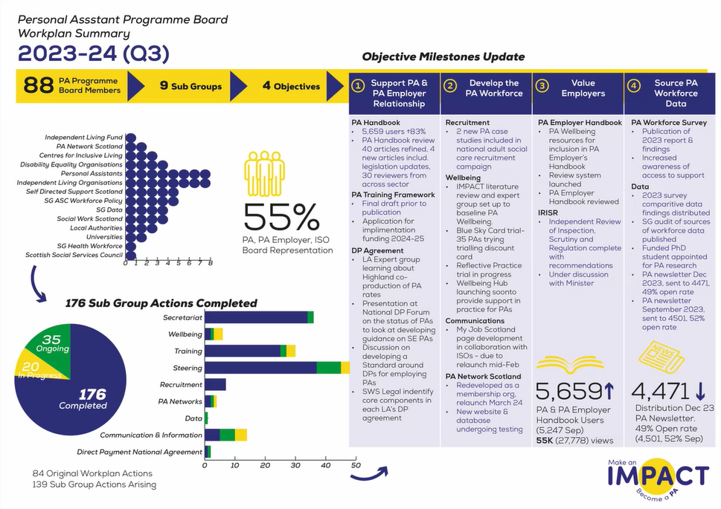

Support in the Right Direction Updates | Actions
Inspiring Scotland are currently waiting for funding approval in order to confirm the next round of SiRD funding across Scotland.

CB and LH gave a presentation about the work of Voice Of Carers Across Lothian (VOCAL).

(double click to access these slides)

Comments and questions:
DMd – Are carers able to access a carer’s assessment across the board, or is this more accessible to some groups?
LH – We see fewer younger adult carers, while we have the lowest number of referrals for carers of people with mental health or substance abuse. The issue seems to be with identifying as a carer.
CB – There is recognition that carers of people with substance abuse need support, but it’s early days at this stage.

LP – You mentioned a reduction in support having an impact on carers’ ability to work, and people, particularly women, having to leave employment because of this. How challenging is it to reach people who don’t identify as carers, primarily those of other genders, who may want to access services?
LH – We are seeing more identification of carers following the COVID pandemic, and we do have a real community focus, to identify where carers are going, not necessarily for carer support, and how do we have those conversations? It might be supermarkets or employers thinking about this to help to identify carers. As well as recognising that someone is a carer, the second part is to make them aware that they have rights and that support is available. It’s on average seven years between when someone becomes a carer and when they might access support. Sometimes all people need at an early stage is the welcome pack and to know that support is available, and then they will feel more confident to access support when they do need it.

AMM – We need to continue to keep an eye on the number of women who are carers, especially in the context of monitoring the proportion of women who are in work. Many people do want to care for their family members, but they can’t make it affordable, so it comes in a range of different layers.
LH – Yes, it’s often women who are most affected, though there are many male carers.

KP – I’m in that group you mentioned "females currently working" . As a carer I always fear that this can stop at any minute for me and working is a huge part of my identity and keeps my mental health well. I feel part of a hidden group - unpaid carers in employment. i don’t engage with my carers centre so feel hidden in the system.

MHJ - Really interesting to hear about the term 'replacement care'. I wonder how Local Authorities calculate what an appropriate level of replacement care is? Does it depend a bit on what the carer feels able to continue to provide?

JMe – Do you have any stats on the proportion of care plans that are successful when they go to Social Work?
CB – I don’t have figures to hand, but I have recently heard that 95% of the plans submitted in Lothian go on to receive statutory support, which I expect were mostly respite packages, so this was reassuring in terms of identifying the right outcomes in plans. In Midlothian, many of the plans created can be met in-house, so very few plans actually go to Social Work.
PN - That's amazing. Even higher than advocacy support for welfare appeals success (compared with those that don't get support).
LH – We have also been fortunate in that Midlothian are keen to make the best outcome for carers, and to turn that around as quickly as possible, though our experience is that not all Local Authorities are like that. They all work very differently.

Scottish Government Update | Actions
JF gave a brief update on behalf of Scottish Government. Funding applications are in for SDS projects so the SDS improvement team are working on that, as well as on the SiRD funding.

The SDS improvement team will be able to give a fuller update on monitoring and evaluation of the SDS improvement plan at the next meeting of this group.

TF added that grant proposals are being looked at just now, reports on PA data sources and the PA workforce survey will be looked at in the PA Programme, through the data subgroup.

Any Other Business | Actions
The next meeting of this group will be on 6th March 2024.

